**Project Stage V   
Covid 19 Data Analysis Dashboard**  
  
**Initial view of the main graph and the trend line using moving average**Mode selection: Linear on the number of Cases and Deaths:

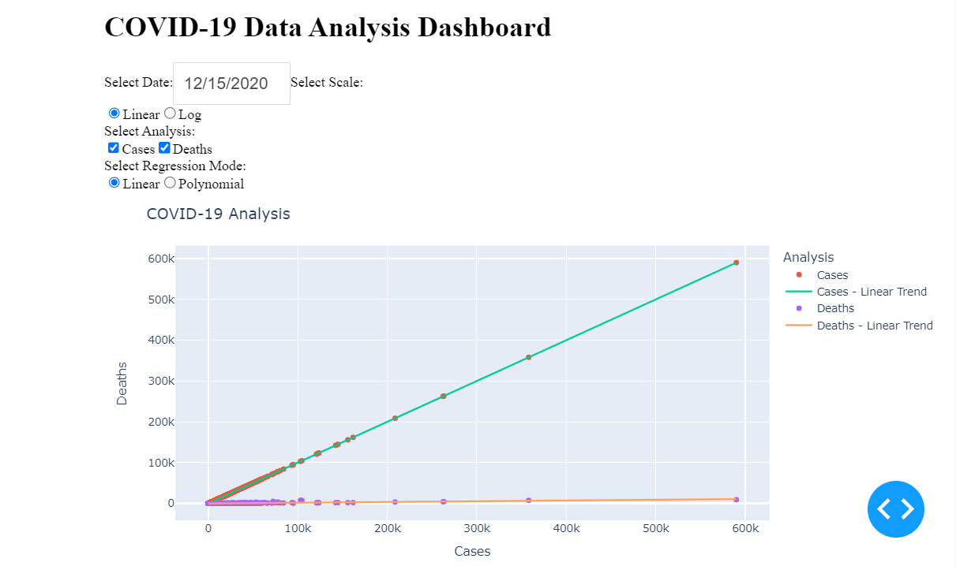

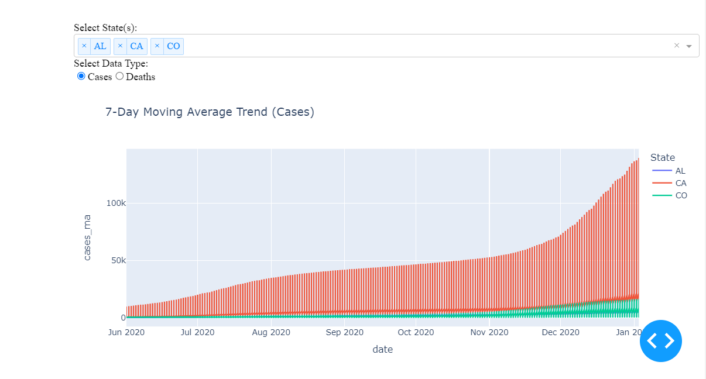

Mode selection: Log on the number of Cases and Deaths:

Polynomial Prediction Trend line with linear number of cases and deaths:

Cases trend using moving average for Single State

Deaths trend using moving average for Single State

Deaths trend using moving average for multiple states

Cases trend using moving average for multiple states.

